Genotyping by copy number: setting up reactions for qPCR with Dot1I2 and Neo assays in separate wells

The following protocol deals purely with the process of setting up reactions for copy number genotyping and qPCR. Please see other protocols for DNA extraction, setting up plate records and running the qPCR machine.
The endogenous control is the Dot1l gene, and the target reporter is the Neo gene.
Both TaqMan™ assays are labeled with FAM dye, therefore the reactions have to be performed in different wells, but on the same plate. TaqMan™ assays are supplied by Applied Biosystems and contain the forward, reverse and labeled probe primers in one tube at the correct concentration ratios. If using separate primers and probes please refer to Applied Biosystems for the primer concentrations to use.
PCR is performed on an Applied Biosystems 7900HT qPCR machine.

Reagents:
- DNA prepared using the Applied Biosystems Sample-to-SNP method (stored at -20°C).
- Applied Biosystems GTXpress™ Master Mix (stored at 4°C)
- TaqMan™ Dot1l2 assay 60x conc (aliquot and store at -20°C)
- TaqMan™ Neo assay 60x conc (aliquot and store at -20°C)

Protocol:
- Fully thaw out assay aliquots and store on ice along with the master mix. DNA should be thawed out and left at room temperature.
- Centrifuge the DNA plate (Rotanta460; 5000rpm; 48s).
- Reactions are set up as a 10µl volume with the following reagents (one assay per well).

Reaction mix
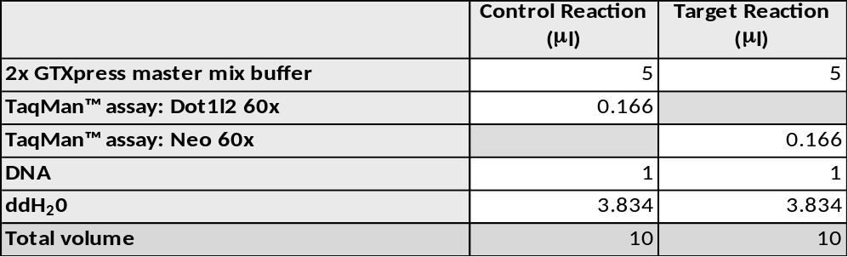

- When adding the DNA, stir it briefly with the pipette prior to aspiration. This ensures re-suspension of the DNA.

- Once the plate is set up, seal it with ABI optical clear film.
- Centrifuge the plate briefly to ensure any air bubbles are removed from the bottom of the well.
- Load the plate on to the qPCR machine and run the samples on the ΔΔCt (RQ) module.

Part numbers:
TaqMan ™GTXpress™ Master Mix, 1-Pack (10 mL) 4401892 4000 reactions
TaqMan™GTXpress™ Master Mix, 5-Pack (50 mL) 4401890 20000 reactions
MicroAmp™ Optical Adhesive Film 4311971 100 pack
MicroAmp Fast Optical 96-Well Reaction Plate 0.1 ml 4346906 20 pack
MicroAmp™ Optical 384-Well Reaction Plate 4309849 50 pack

Sequences:
Forward Primer Name |  | Forward Primer Seq.
NeoF |  | GGTGGAGAGGCTATTCGGC
Dot1l_2F |  | GCCCCAGCACGACCATT
Reverse Primer Name |  |  | Reverse Primer Seq.
NeoR |  |  | GAACACGGCGGCATCAG
Dot1l_2R |  |  | TAGTTGGCATCCTTATGCTTCATC
Reporter 1 Name |  |  | Reporter 1 Dye |  | Reporter 1 Sequence
NeoM1 |  |  | FAM |  | TGGGCACAACAGACAATCGGCTG
Dot1l_2M1 |  |  | FAM |  | CCAGCTCTCAAGTCG

qPCR Cycling conditions
Cycle
1 95ºC 20sec
2 95ºC 10sec
3 60ºC 30sec
4 Go to ‘2’ + 34 cycles
Set volume to 10ul

These conditions apply to samples run on either 384 well plates or 96 well plates on a FAST block. 96 well plates run on a standard block may require amplification conditions to be altered.

